Machine Learning Proof of Concept: Wheat Price Forecasting in Uttar Pradesh
Objective
The primary objective of this Proof of Concept (POC) is to demonstrate the feasibility of building a machine learning model to forecast monthly wheat prices in Uttar Pradesh, India. The POC explores the use of historical price data combined with climate data as potential explanatory variables to improve forecasting accuracy.
Data Sources
- AGMARKNET Daily Prices: Daily prices for Wheat in various markets across Uttar Pradesh, sourced from the data.gov.in AGMARKNET API and manually uploaded files.
- POWER Climate Data: Monthly climate data (temperature, rainfall, humidity, wind speed) for selected districts in Uttar Pradesh, used as exogenous variables in the forecasting model.
Methodology
The POC follows a standard machine learning workflow for time series forecasting:
- Data Acquisition: Price data is collected from both the AGMARKNET API for a 5-year window and processed from manual Excel/CSV files. Climate data is loaded from a pre-processed CSV file.
- Data Processing and Standardization:
  - Daily price data is aggregated to weekly (Saturday) and monthly (month-end) frequencies.
  - Climate data is standardized and aggregated to the state level (Uttar Pradesh) by taking the mean across selected districts.
  - A combined monthly dataset is created by joining the processed price and climate data on the month-end date.
- Feature Engineering: New features, such as Diurnal Temperature Range (DTR) and the logarithm of rainfall, are created from the climate data.
- Exploratory Data Analysis (EDA): Various visualizations are generated to understand the trends, seasonality, and relationships within the data:
  - Time series plots of monthly prices, rainfall, and temperature.
  - Boxplot to visualize price seasonality by calendar month.
  - Scatter plot to examine the relationship between price and rainfall.
  - Plot of recent weekly price trends.
- Model Selection and Backtesting:
  - A Seasonal Autoregressive Integrated Moving Average with Exogenous Regressors (SARIMAX) model is selected for forecasting.
  - The model is backtested on a 12-month holdout period to evaluate its performance against a seasonal naive baseline.
  - Evaluation metrics such as Root Mean Squared Error (RMSE) and Mean Absolute Percentage Error (MAPE) are used to compare model performance.
- Model Refitting and Forecasting:
  - The SARIMAX model is refitted on the entire available dataset.
  - A 12-month forecast of monthly wheat prices is generated. Future climate exogenous variables are handled using a simple climatology approach (repeating the last 12 months of observed climate data).
Results and Insights
- The notebook successfully acquires and processes historical price and climate data for Uttar Pradesh.
- EDA provides insights into the seasonality of wheat prices and the relationship between price and climate variables like rainfall and temperature.
- The SARIMAX model with climate covariates generally outperforms the seasonal naive baseline in the backtesting period, indicating the potential value of including climate information in the forecasting model.
- A 12-month forecast of monthly wheat prices is generated, providing potential future price ranges with an 80% confidence interval.
This POC demonstrates a basic framework for building a commodity price forecasting model using publicly available data and standard time series techniques. Further improvements could involve exploring more advanced models, incorporating additional relevant features, and refining the handling of future exogenous variables.

Unit I – Introduction to Robots
- Define a robot. Explain the major events in the development of industrial robots with examples.
- Explain different components of an industrial robot with a neat block diagram.
- What do you understand by degrees of freedom? Differentiate between degrees of freedom and degrees of movement with suitable examples.
- List the various types of joints used in robots and discuss their significance in industrial applications.
- Define control resolution, spatial resolution, accuracy, and repeatability. Explain the factors affecting them.
- Describe the various actuators, drives, and transmission systems used in robotics with suitable examples.

Unit II – Time and Motion
- Explain smooth one-dimensional trajectory planning with an example. Extend your explanation to multi-segment trajectories.
- What is Cartesian motion? Differentiate it from joint-space motion with examples.
- Explain interpolation of orientation in 3D. Why is it important in industrial robots?
- Write short notes on incremental motion and time-varying coordinate frames with examples.
- Discuss the concept of inertial navigation systems. How are they applied in mobile robot vehicles?
- With neat sketches, explain the motion of car-like mobile robots in terms of:
(a) Moving to a point
(b) Following a line
(c) Moving to a pose

Industrial Robotics & Automation – Question Bank
- What are major events in the development of industrial robots.
- Explain different components of an industrial robot with block diagram?
- What do you understand by degree of freedom of robot?
- List the various types of joints used in robots.
- Define Kinematics, workspace & trajectory.
- What are the types of wrist motions?
- In a sentence or two, define frame, and position control.
- In a sentence or two, define force control, and robot programming language.
- In a sentence or two, define nonlinear control, and off-line programming.
- How are robots classified based on geometry?
- Identify various types of robot control.
- Distinguish between point-to-point and continuous path motion of a robot.
- What is a work envelope of a robot?
- Define accuracy. Define precision.
- What is the importance of the work envelope of a robot?
- Distinguish between accuracy and repeatability of a robot.
- Classify robots on the basis of path movement.
- List the parameters used for selection of a robot for a particular application.
- State the major subsystems of a robot and their functions.
- Show these subsystems on a sketch.
- Describe briefly the various types of motion controls possible in robots.

Visualizing Classifier Decision Boundaries

Visualizing classifier decision boundaries is a way to gain intuitive insight into how machine learning models separate different classes in a feature space. These visualizations help us understand model behavior by showing which regions of input space are classified into which categories. They can highlight issues like overfitting or underfitting and reveal how features interact in classification. Typically done in two dimensions either by using datasets with only two features or by applying dimensionality reduction.

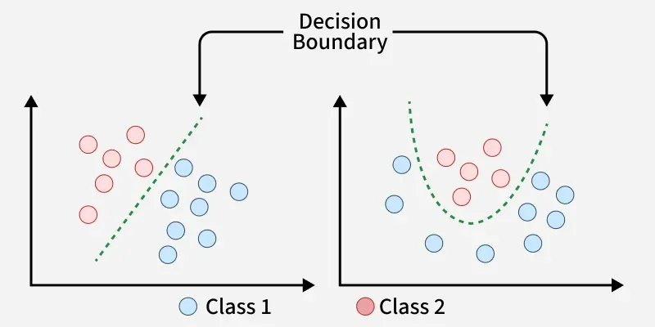

Decision Boundary
Decision Boundary
- A decision boundary is the dividing line or surface that separates different classes in a classification problem.
- It represents the region in the feature space where the classifier changes its predicted label from one class to another.
- For example in a two dimensional dataset this boundary might appear as a straight line or a curved shape depending on the complexity of the model.
- Visualizing decision boundaries helps us understand how a model distinguishes between classes, reveals patterns in the data and can indicate issues like overfitting or poor generalization.

Understanding Decision Boundaries in K-Nearest Neighbours (KNN)

A decision boundary is a line or surface that divides different groups in a classification task. It shows which areas belong to which class based on what the model decides. K-Nearest Neighbours (KNN) algorithm operates on the principle that similar data points exist in close proximity within a feature space. The shape of this boundary depends on:
- The value of K (how many neighbours are considered).
- How the data points are spread out in space.
For example given a dataset with two classes the decision boundary can be visualized as the line or curve dividing the two regions where each class is predicted. For a 1-nearest neighbor (1-NN) classifier the decision boundary can be visualized using a Voronoi diagram.

Using Voronoi Diagrams to Visualize
- A Voronoi diagram splits space into regions based on which training point is closest.
- Each region called a Voronoi cell contains all the points closest to one specific training point.
- The lines between regions are where points are equally close to two or more seeds. These are the decision boundaries for 1-Nearest Neighbour which is very irregular in shape.
- If we label the training points by class the Voronoi diagram shows how KNN assigns a new point based on which region it falls into.
- The boundary line between two points pipi​ and pjpj​is the perpendicular bisector of the line joining them meaning it’s a line that cuts the segment between them exactly in half at a right angle.
Formation of Decision Boundaries

Relationship Between KNN Decision Boundaries and Voronoi Diagrams
In two-dimensional space the decision boundaries of KNN can be visualized as Voronoi diagrams. Here’s how:
- KNN Boundaries: The decision boundary for KNN is determined by regions where the classification changes based on the nearest neighbors. K approaches infinity, these boundaries approach the Voronoi diagram boundaries.
- Voronoi Diagram as a Special Case: When k = 1 KNN’s decision boundaries directly correspond to the Voronoi diagram of the training points. Each region in the Voronoi diagram represents the area where the nearest training point is closest.

How KNN Defines Decision Boundaries
In KNN, decision boundaries are influenced by the choice of k and the distance metric used:
1. Impact of 'K' on Decision Boundaries: The number of neighbors (k) affects the shape and smoothness of the decision boundary.
- Small k: When k is small the decision boundary can become very complex, closely following the training data. This can lead to overfitting.
- Large k: When k is large the decision boundary smooths out and becomes less sensitive to individual data points, potentially leading to underfitting.
2. Distance Metric: The decision boundary is also affected by the distance metric used like Euclidean, Manhattan. Different metrics can lead to different boundary shapes.
- Euclidean Distance: Commonly used leading to circular or elliptical decision boundaries in two-dimensional space.
- Manhattan Distance: Results in axis-aligned decision boundaries.
